# PREDICTION ALGORITHM FOR THE ACHIEVEMENT OF TEST “SABERPRO”

***David Restrepo Ramírez***

***Juan Felipe López Gutiérrez***

*Medellin, May 21st, 2020.*

# Designed Data Structure

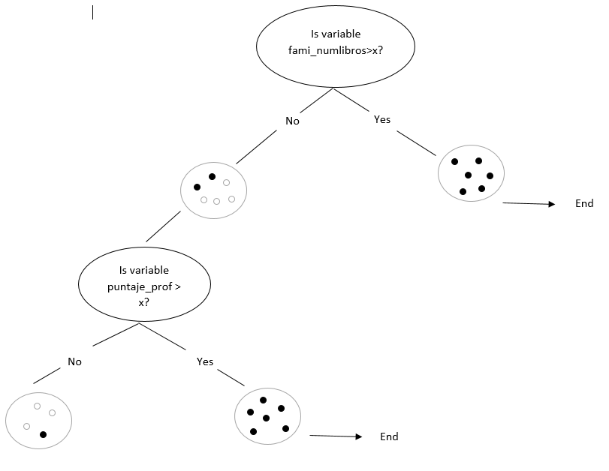

***Picture 1:*** CART data structure evaluates and creates new child nodes based on the results it obtains.

# Data Structure Operations

**Table 1:** Table to report complexity analysis of the matrix to proceed with the next variables.

**Picture 2:** CART tree algorithm is going through the dataset. as it finds the lowest Gini impurity

which divides the data, it creates nodes with

conditions and takes the variable processed out

# Design Criteria of the Data Structure

Decision trees are good for sorting, searching and storing big volumes of data with a low Big-O complexity.

CART (Classification and Regression Tree) algorithm is a good decision tree implementation which can be easily managed recursively. It provides a clear and simple comprehension of the structures that are being created which filter and classify the data.

# Time and Memory

**Table 2:** Execution time of the operations

**Table 3:** Memory used for each operation of the data structure for each data set of the data structure and for each data set.

